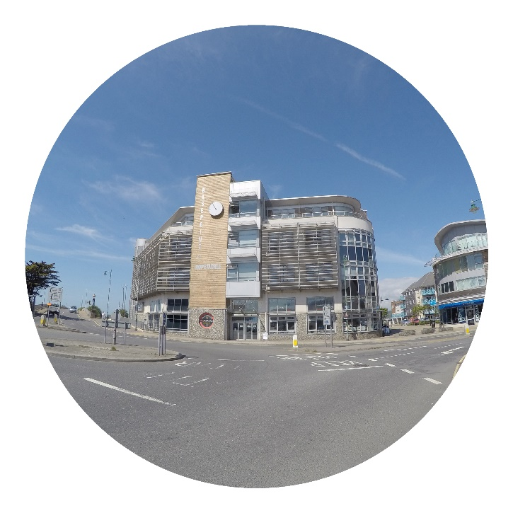
Shoreham’s multi-award winning Ropetackle Arts Centre celebrates its 10th anniversary by launching a Business Friends’ scheme.
This exciting new project offers local businesses – along with those from further afield – the opportunity to share in our centre’s remarkable success.
Who we are
Ropetackle is a community-owned charity, run by a board of unpaid trustees and some 80 volunteers, supported by a small professional team. They all share a combined passion for the community and the arts, and dedication to the centre’s continued success.
Over the past 10 years, Ropetackle has established itself as one of the most vibrant and distinctive arts venues in the region, combining its programme of top level arts and entertainment with a rich and diverse mixture of community activities.
What we do
From jazz festivals to comedy nights, classical music to rock, spoken word to film, Ropetackle has something for everybody and aims to appeal to all sectors of the community and people from all walks of life.
With a 200-seat auditorium (350 standing), a spacious foyer and 40 capacity mezzanine, Ropetackle is ideal for a wide range of activities, meetings, conferences and exhibitions, which run alongside our arts and educational programmes.

Attracting audiences of around 30,000 per year, Ropetackle runs a Friends’ scheme supported by 750 members, and a mailing list of 15,000+ subscribers. It also benefits from wide support from a large number of other users and visitors.
Ropetackle plays a unique and established role at the heart of the community as well as being a hugely valued contributor to the local economy and a principal amenity asset.
By joining our Business Friends scheme, you can be part of Ropetackle’s remarkable story. Benefits include:
- Promoting your brand to a wide and diverse audience
- Strengthening your community social responsibility
- Ongoing recognition of your contribution to the community
- Networking with other business and individuals making similar contributions
- Enhancing your reputation with customers and clients
- Strengthening the ethos of your business
- Adding value to your staff relations
- Offering opportunities for active involvement
- Generating appealing ways to entertain clients and guests
There is also the opportunity to become actively involved – following the example of Pembroke Financial Services.
“We wanted to give something back to the local community who support us as a Business and as a ‘home’. Ropetackle gives great joy to the community and the fact that the place operates almost entirely by virtue of volunteers who work so hard, made it the perfect choice for us as a ‘community partner’. Becoming a sponsor of Ropetackle has had a remarkable effect on our business both in terms of brand awareness, new business opportunities, and our reputation for being actively engaged in the local community.” ~ Keith Relf (MD)

Membership Options
We can offer a several different levels of Business Friends’ membership:
- Business Friend
- Name displayed at Ropetackle
- Accreditation in our eye-catching programmes and on our website
- Name displayed on screen at beginning of shows
- Accreditation certificate for display at your premises
- Invitation to Business Friends’ receptions (2 per year)
- Other benefits as offered to Friends

Subscription: £250 per year *
- Business Friend Sponsor

The benefits of Business Friends, plus:

- Advert in the printed programme, on our website and on the pre-show screen
- Your name cited as sponsor of 2 events per year*
- Website links
- Other benefits (e.g. sponsoring specific projects, facilities, etc.)

Subscription: £1,000-£2,000 per year * according to benefits

- Business Friend Principal Sponsor

The benefits of Business Friends Sponsors, and plus:

- Exclusivity (only one Principal Sponsor in each business category)
- Your name cited as sponsor of 3 events per year*
- Opportunity to host a reception before one of such events
- Complementary tickets for such event
- Marketing material displayed in foyer
- Sponsoring major community projects
- Other benefits subject to agreement

Subscription: £5,000- £10,000 * per year according to benefits

For more information and to organise an informal, no obligation chat, please contact Martin Allen at admin@ropetacklecentre.co.uk (subject: ‘Business Friends’) or telephone 01273 464440
* Plus VAT

